Accommodation at Rangemore Estate is offered in the form of either 2x1 bedroom cabins or
Three bedroom Cottage
Both 1 bedroom cabins are fully self contained with their own kitchen, ensuite and verandah.
The cottage is fully self contained with its own kitchen, 3 bedrooms, bathroom and verandah.
Both accommodations come supplied with linen and bedding.
Meals are a choice between self catered with estate poultry and beef/goat available or homestyle cooking by arrangement.
 | 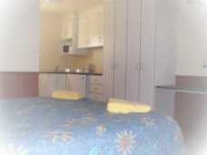 | 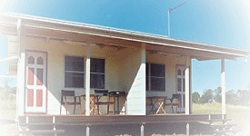 | All accommodation is nonsmoking.
 | One bedroom cabins |  | One bedroom cabins from outside
 |  | 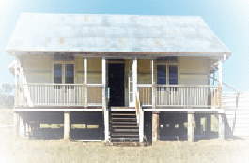
 |  | Three bedroom cottage

Unique camping facilities with toilets and showers are also available in a vineyard and bush setting.
Bookings are available by phone (0419647994 or e-mail rangemoreestate@bigpond.com
Linda and Dave welcome visitors of all ages into the peace and tranquillity of farm life and country hospitality.

RANGEMORE ESTATE
366 MALLING-BOUNDARY
MACLAGAN 4352

